ML_Assignment_1

VijayKumar Reddy Almalachervu

Kent id: valmalac

13/02/2022

**##import dataset**

student_marks <- read.csv(file = "C:/Users/vijay/Downloads/student_marks.csv")

library(fBasics)

## Loading required package: timeDate

## Loading required package: timeSeries

**##Descriptive stats**

##Calculating summary stats for all the columns of data set

summary(student_marks)

## Name Gender DOB Maths

## Length:5 Length:5 Length :5 Min. :25.0

## Class :character Class :character Class :character 1st Qu. :55.0

## Mode :character Mode :character Mode :character Median :58.0

Mean :58.2

3rd Qu :75.0

Max. :78.0

## Physics Chemistry English Biology Economics

## Min. :45 Min. :56.00 Min. :46.0 Min. :21.0 Min. :52.0

## 1st Qu.:54 1st Qu.:72.50 1st Qu.:63.0 1st Qu.:54.0 1st Qu.:61.0

## Median :55 Median :82.00 Median :64.0 Median :90.0 Median :77.0

## Mean :61 Mean :77.25 Mean :67.2 Mean :71.2 Mean :73.2

## 3rd Qu.:55 3rd Qu.:86.75 3rd Qu.:76.0 3rd Qu.:95.0 3rd Qu.:87.0

## Max. :96 Max. :89.00 Max. :87.0 Max. :96.0 Max. :89.0

## NA’s :1

## History Civics

## Min. :56.0 Min. : 2.0

## 1st Qu.:58.0 1st Qu.:45.0

## Median :75.0 Median :53.0

## Mean :72.2 Mean :47.8

## 3rd Qu.:83.0 3rd Qu.:65.0

## Max. :89.0 Max. :74.0

**##Calculation of Summary Statistics**

**##mean**

mean(student_marks$Maths)

## [1] 58.2

mean(student_marks$Chemistry, na.rm = TRUE)

## [1] 77.25

**##median**

median(student_marks$Physics)

## [1] 55

median(student_marks$Chemistry, na.rm = TRUE)

## [1] 82

**##standard deviation**

sd(student_marks$Maths)

## [1] 21.13528

**##max value in specific column of dataset**

max(student_marks$Economics)

## [1] 89

##min value in specific column of dataset

min(student_marks$Biology)

## [1] 21

**##Range**

range(student_marks$History)

## [1] 56 89

**##mode**

mode(student_marks$Maths)

## [1] "numeric"

##Transforming a variable

Transform(student_marks,Maths = Maths + 5)

## Name Gender DOB Maths Physics Chemistry English Biology Economics

## 1 John M 5/4/88 60 45 56 87 21 52

## 2 Suresh M 4/5/87 80 55 NA 64 90 61

## 3 Ramesh M 25/5/1989 30 54 89 76 95 87

## 4 Jessica F 12/8/90 83 55 86 63 54 89

## 5 Jennifer F 2/9/89 63 96 78 46 96 77

## History Civics

## 1 89 65

## 2 58 2

## 3 56 74

## 4 75 45

## 5 83 53

Transform(student_marks, Accounts = c(89,88,45,37,76))

## Name Gender DOB Maths Physics Chemistry English Biology Economics

## 1 John M 5/4/88 55 45 56 87 21 52

## 2 Suresh M 4/5/87 75 55 NA 64 90 61

## 3 Ramesh M 25/5/1989 25 54 89 76 95 87

## 4 Jessica F 12/8/90 78 55 86 63 54 89

## 5 Jennifer F 2/9/89 58 96 78 46 96 77

## History Civics Accounts

## 1 89 65 89

## 2 58 2 88

## 3 56 74 45

## 4 75 45 37

## 5 83 53 76

**Plot**

Plot(student_marks$Maths)

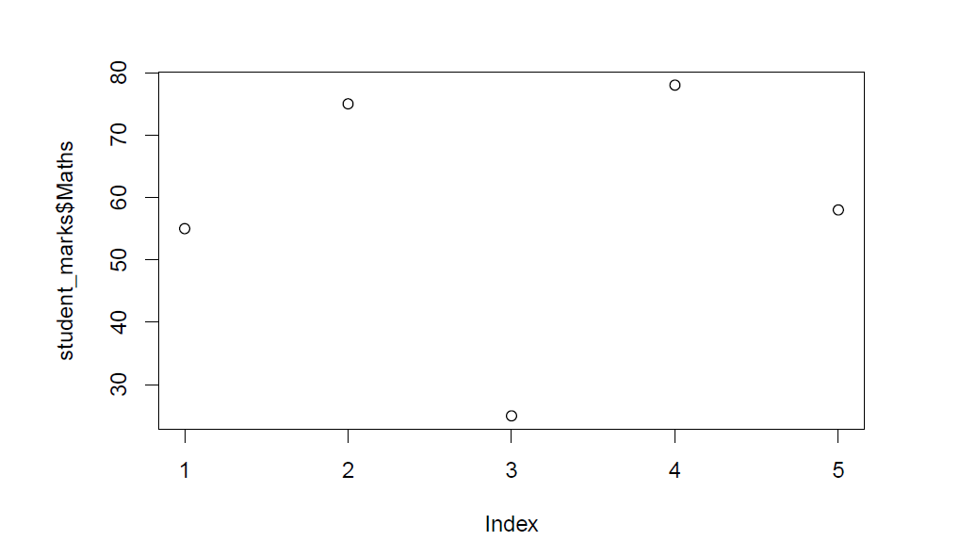

**Plot Histogram**

Hist(student_marks$English)

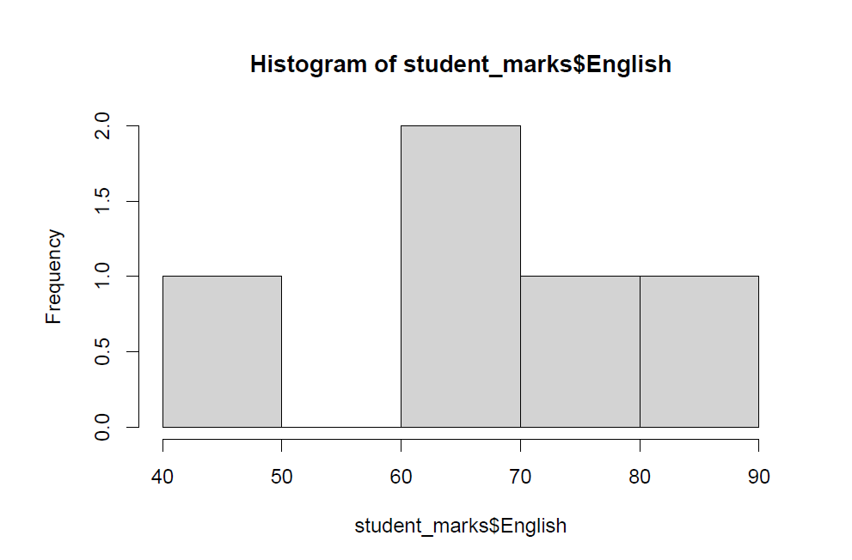

**Scatter Plot**

Plot(student_marks$Physics, student_marks$civics)

